A Community Engagement Project (CEP) Report
On
“OPEN-SOURCE SOLUTION FOR SOCIAL NEEDS”
“LOCAL BIODIVERSITY MAPPING OF BYCULLA ZOO
AND SURROUNDING GREEN SPACES”
(A Geospatial Biodiversity Census, Web-GIS Cartography & Community Ecological Literacy Study)
Submitted by
RIDDHESH KENI (Roll No: 35)
SHIVANSH DUBEY (Roll No: 45)
In partial fulfillment for the award of the degree of
BACHELOR OF SCIENCE in COMPUTER SCIENCE
(T.Y. B.Sc. CS — Semester V, NEP 2020 Guidelines)
under the guidance of
PROF. Shweta Iyer
Department of Computer Science

VIDYAVARDHINI’S
A. V. COLLEGE OF ARTS, K. M. COLLEGE OF COMMERCE, E. S. A. COLLEGE OF SCIENCE
(VARTAK COLLEGE)
(Affiliated to University of Mumbai)
VASAI ROAD (WEST), PALGHAR – 401202, MAHARASHTRA
(SEM-V) • ACADEMIC YEAR: (2026 – 2027)

VIDYAVARDHINI’S
A. V. COLLEGE OF ARTS, K. M. COLLEGE OF COMMERCE, E. S. A. COLLEGE OF SCIENCE
(VARTAK COLLEGE)
(Affiliated to University of Mumbai)
Vasai Road (West), District Palghar – 401202, Maharashtra
DEPARTMENT OF COMPUTER SCIENCE
――――――――――――――――――――――――――――――――――――――――――――――
CERTIFICATE
This is to certify that Mr. RIDDHESH KENI (Roll No. 35) and Mr. SHIVANSH DUBEY (Roll No. 45), students of Vidyavardhini’s A. V. College of Arts, K. M. College of Commerce, E. S. A. College of Science (Vartak College), studying in the Bachelor of Science in Computer Science (T.Y. B.Sc. CS — Semester V) program, have satisfactorily completed their Community Engagement Project (CEP) titled:
📜 Approved Community Engagement Project Title
“LOCAL BIODIVERSITY MAPPING OF BYCULLA ZOO AND SURROUNDING GREEN SPACES (A Geospatial Biodiversity Census, Web-GIS Cartography & Community Ecological Literacy Study)”

under the theme “OPEN-SOURCE SOLUTION FOR SOCIAL NEEDS” for the academic year 2026–2027, in partial fulfillment of the requirements for the award of the Degree of Bachelor of Science in Computer Science as per the guidelines formulated by the University of Mumbai under the National Education Policy (NEP 2020) carrying a weightage of two (2) credits.
To the best of my knowledge, the work presented in this report is original, authentic, and the information included in the project is correct.
_______________________  Internal Guide / Mentor  PROF. Shweta Iyer  Dept. of Computer Science | _______________________  Head of the Department  Dept. of Computer Science  Vartak College | _______________________  Principal  Vartak College  Vasai Road (West)
External Examiner Signature: _______________________ Date: ___/___/2026
College Seal / Stamp: Place: Vasai Road (W)

VIDYAVARDHINI’S
A. V. COLLEGE OF ARTS, K. M. COLLEGE OF COMMERCE,
E. S. A. COLLEGE OF SCIENCE,
(Affiliated by University of Mumbai)
Declaration
I, Mr./Ms. _____________________________________________ Student of
________________________________ Institute/college studying in
__________________________________ program, hereby declare that I have completed the
Community Engagement Project titled “LOCAL BIODIVERSITY MAPPING OF BYCULLA ZOO AND SURROUNDING GREEN SPACES (Urban Ecology & Public Awareness Platform)” during the academic year 2026-2027.
The report is original and the information/data included in the report is true emerging from the primary and/or secondary data gathered and analyzed as part of this Community Engagement project.
Due credit is extended on the work of Literature/Secondary Survey by endorsing it in the Bibliography as per prescribed format.
Signature of the Student with date
Name of Student

ACKNOWLEDGEMENT
We would like to express our sincere gratitude to our institution, Vidyavardhini’s A. V. College of Arts, K. M. College of Commerce, E. S. A. College of Science (Vartak College), and the Department of Computer Science for providing us with the opportunity to undertake this Community Engagement Project (CEP) under the National Education Policy (NEP 2020) guidelines.
We are profoundly indebted to our respected Principal, Dr. Arvind Ubale (Principal, Vartak College), for his visionary leadership, institutional support, and encouragement to pursue experiential community learning bridging information technology with real-world social and ecological challenges.
We express our heartfelt thanks to the Head of the Department of Computer Science for granting necessary departmental permissions, providing access to computational resources, and offering valuable guidance during project milestones.
Our deepest gratitude goes to our project guide, Prof. Shweta Iyer, Department of Computer Science, for her expert mentorship, continuous encouragement, and critical review throughout the conceptualization, fieldwork, and documentation stages. Her constructive feedback and supervisory sessions in the Guide Interaction Diary ensured that our work remained methodologically rigorous and strictly compliant with university standards.
We extend our sincere appreciation to the administrative authorities and garden staff of Veermata Jijabai Bhosale Botanical Udyan and Zoo (Byculla Zoo), Brihanmumbai Municipal Corporation (BMC), for granting on-site study permissions. We are especially thankful to the veteran botanical caretakers (malis), notably Mr. Maruti Patil, whose decades of experiential botanical insights regarding heritage trees and avian nesting patterns enriched our observational records.
We also thank the eighty-four community participants—morning walkers, local residents, teachers, and school students—who took time to participate in our surveys and provide actionable user feedback on our live Web-GIS portal (BioMap). Finally, we thank our parents and fellow classmates for their unwavering encouragement.
RIDDHESH KENI (Roll No. 35)
SHIVANSH DUBEY (Roll No. 45)
Third Year B.Sc. (Computer Science)
Vartak College, Vasai

ABSTRACT
This Community Engagement Project, titled “Local Biodiversity Mapping of Byculla Zoo and Surrounding Green Spaces,” was undertaken to address the critical deficit in localized, open-access ecological information within Mumbai’s densely urbanized core. Veermata Jijabai Bhosale Botanical Udyan and Zoo (Byculla Zoo), spanning 53 acres in South Mumbai, represents a vital heritage ecological refugium housing over 3,213 trees across 256 species, alongside critical free-living wildlife populations.
Despite its immense ecological value, primary community interactions (N = 84 participants) revealed a severe biodiversity literacy gap: over 78% of park visitors were unaware of the presence of century-old heritage trees and free-ranging avifauna, primarily because institutional signage is exclusively concentrated on caged zoo animals. To bridge this divide under the theme of “Open-Source Solution for Social Needs,” the investigators conducted an intensive multi-taxa field census coupled with acoustic decibel profiling and geospatial coordinate mapping.
Empirical findings cataloged 42+ distinct species across Mammalia, Aves, Reptilia, Insecta, and Heritage Flora. Mathematical diversity analysis revealed a Shannon-Wiener Diversity Index of H′ = 2.68 within the interior botanical canopy (Zone 1), compared to H′ = 1.48 along the perimeter corridor (Zone 4). Simultaneously, acoustic decibel measurements demonstrated that the multi-tiered botanical canopy provides an acoustic damping effect of 26.3 dB, reducing ambient noise from 78.4 dBA at the perimeter traffic boundary to 52.1 dBA in the interior grove, sustaining sensitive avian breeding pairs.
To translate these scientific observations into community action, the authors developed and deployed an open-source, mobile-responsive Web-GIS cartographic platform (BioMap, accessible live at biomap-byculla.netlify.app) utilizing OpenStreetMap and Leaflet.js. The platform provides interactive geolocation markers, bilingual vernacular ecological descriptions (Marathi and English), and micro-zone boundary overlays. This study delivers a three-tier municipal conservation blueprint proposing QR-coded botanical signage, acoustic vegetative buffers, and citizen-science integrations for the BMC Tree Authority.
📊 Key Project Outcomes & Metrics
• 42+ verified species cataloged with GPS vouchers | • Shannon Index H′ = 2.68 (Interior) vs. 1.48 (Perimeter)
• 26.3 dBA acoustic noise attenuation measured | • Live open-source Web-GIS deployed on Netlify
• 84 community stakeholders surveyed & analyzed | • 3-tier municipal policy blueprint for BMC Tree Authority

Keywords: Urban Biodiversity Mapping, Byculla Zoo, Open-Source Web-GIS, Shannon-Wiener Index, Acoustic Buffering, Community Engagement, NEP 2020.

TABLE OF CONTENTS
Preliminary Sections and 5-Chapter Scheme (NEP 2020 Guidelines)
Section / Ch. | Title / Subject Matter | Page
Prelim | Acknowledgement | 1
Prelim | Abstract | 2
Prelim | List of Figures and Tables | 4
CHAPTER 1 | INTRODUCTION | 5
1.1 | Purpose of the Visit | 5
1.2 | Background Information | 5
1.3 | Significance | 6
1.4 | Scope of the Report | 6
CHAPTER 2 | LITERATURE REVIEW | 7
2.1 | Introduction | 7
2.2 | Urban Ecological Refugia & Historical Context | 7
2.3 | Citizen Science & Community Participation | 7
2.4 | Existing Biodiversity Platforms & Data Deficits | 8
2.5 | Technological Solutions & Open-Source Geospatial Mapping | 8
2.6 | Relevance to the BioMap Proposal | 9
CHAPTER 3 | METHODOLOGY | 10
3.1 | Data Collection Approach | 10
3.2 | Sampling Method & Survey Zones | 10
3.3 | Field Study and Location Evidence | 11
3.4 | Data Analysis & Quantitative Diversity Metrics | 11
3.5 | Rationale for the Selected Methods | 11
Table of Contents (Continued)
Section / Ch. | Title / Subject Matter | Page
CHAPTER 4 | COMMUNITY INTERACTIONS, OBSERVATIONS & ANALYSIS | 12
4.1 | Community Interactions and Multi-Stakeholder Engagement | 12
4.2 | Field Observations & Location-Based Species Evidence | 13
4.3 | Survey Findings and Quantitative Analysis | 15
4.4 | Consolidated Key Findings | 17
4.5 | Analysis in Relation to Study Objectives & Web-GIS Portal | 18
CHAPTER 5 | CONCLUSION AND RECOMMENDATIONS | 19
5.1 | Conclusion | 19
5.2 | Recommendations & Three-Tier Municipal Blueprint | 19
References | Academic References & Bibliography | 21
Appendices | Appendix A, B, C (Questionnaire, Architecture, Evidence) | 22
• GUIDE INTERACTION DIARY FORM (10 Scheduled Guidance Meetings): Page 24
• STUDENT FEEDBACK ON CEP (Student Evaluation & Aspects of CEP Experience): Page 25

LIST OF FIGURES AND TABLES
LIST OF FIGURES
Figure No. | Figure Caption / Description | Page
Figure 4.1 | Location 1 – Botanical Grove (Heritage Canopy, Zone 1) | 13
Figure 4.2 | Location 2 – Freshwater Wetland & Lotus Lake (Zone 2) | 13
Figure 4.3 | Location 3 – Promenade Shrublands & Lawns (Zone 3) | 13
Figure 4.4 | Location 4 – Perimeter Transition Buffer (Zone 4) | 13
Figure 4.5 | Survey: Where Is Free-Living Wildlife Observed? | 15
Figure 4.6 | Survey: What Threatens Free-Living Flora & Avifauna? | 15
Figure 4.7 | Survey: Main Barriers to Local Biodiversity Literacy | 16
Figure 4.8 | Survey: Would an Interactive Web App or Website Help? | 16
Figure 4.9 | Survey: Would Citizens Actively Use the Digital Platform? | 16
Figure 4.10 | Survey: What Information Should a Species Listing Include? | 17
Figure 4.11 | Survey: How Should People Discover Available Flora & Fauna? | 17
Figure 4.12 | Survey: Is Citizen Biodiversity Logging Support Useful? | 17
Figure 4.13 | Live BioMap Web-GIS Platform Interface (biomap-byculla.netlify.app) | 18
LIST OF TABLES
Table No. | Table Title / Description | Page
Table 1.1 | Core Challenges Addressed by the Project | 6
Table 1.2 | Research Objectives and Verification Milestones | 6
Table 3.1 | Delineation of Ecological Survey Zones (Z1–Z4) | 10
Table 3.2 | Field Data Indicators & Ecological Census Parameters | 10
Table 3.3 | Hardware, Software & Geospatial Instrumentation Stack | 11
Table 4.1 | Consolidated Key Findings of the Study | 17
Table 5.1 | Three-Tier Municipal Conservation Action Plan | 20

CHAPTER 1
INTRODUCTION
――――――――――――――――――――――――――――――――――――――――――――――
1.1 Purpose of the Visit
As part of the experiential learning curriculum mandated under the National Education Policy (NEP 2020) by the University of Mumbai, students of Bachelor of Science in Computer Science are required to execute a field-based Community Engagement Project (CEP) carrying two credits. The overarching theme assigned to this cohort is “Open-Source Solution for Social Needs.” Under this mandate, the student investigators undertook an intensive on-site ecological and geospatial assessment of Veermata Jijabai Bhosale Botanical Udyan and Zoo (commonly designated Byculla Zoo), situated in Byculla, Mumbai.
The fundamental purpose of this fieldwork was to transition from theoretical computational abstractions to empirical community problem-solving. Urban green spaces in Mumbai face acute anthropogenic encroachment, yet community literacy regarding local wildlife, heritage arboriculture, and ecosystem services remains critically depressed. The field visit was structured to audit living taxa across four micro-ecological zones, document habitat fragmentation, gather primary qualitative and quantitative data from park visitors and caretakers, and establish an empirical baseline to engineer an open-access Web-GIS public cartography portal.
1.2 Background Information
Established in 1861 and sprawling across 53 contiguous acres in South-Central Mumbai, Veermata Jijabai Bhosale Botanical Udyan and Zoo is the oldest public garden in the Mumbai metropolitan region and one of the oldest in India. Beyond its widely recognized role as an institutional menagerie exhibiting captive exotic animals (such as Humboldt penguins and Royal Bengal tigers), the facility encompasses a critically important botanical arboretum harboring 3,213 accessioned trees spanning 256 distinct species. Many of these specimens—notably the African Baobab (Adansonia digitata), Ghost Tree (Sterculia urens), and Ceylon Ebony (Diospyros ebenum)—are historical heritage relics dating back to colonial-era botanical introductions.
In a megalopolis characterized by hyper-dense concrete infrastructure and per-capita open space ratios falling below 1.2 square meters per resident, Byculla Zoo acts as an irreplaceable ecological refugium. It provides critical microclimatic cooling, acoustic attenuation against intense traffic noise, carbon sequestration, and indispensable feeding and breeding grounds for free-living migratory avifauna, chiropterans (fruit bats), and lepidopteran pollinators.

1.3 Significance
The significance of this project lies in establishing an interdisciplinary bridge between applied Computer Science and municipal conservation ecology. Municipal conservation in Indian metropolitan centers often suffers from data asymmetry: citizens lack accessible digital information to appreciate local ecology, while civic authorities lack crowdsourced telemetry to track habitat pressures. This project directly addresses these challenges:
Table 1.1: Core Challenges Addressed by the Project
Identified Deficit | Technological & Community Resolution
Ecological Illiteracy | 91% of visitors bypass heritage trees; resolved via open-access Web-GIS digital flora profiles.
Acoustic Encroachment | Severe traffic noise (78+ dB) on Ambedkar Rd; quantified via spatial sound decibel mapping.
Missing Spatial Data | Absence of public GIS boundary layers; addressed by publishing open GeoJSON coordinates.
Table 1.2: Research Objectives and Verification Milestones
Primary Objective | Target Deliverable & Evaluation Milestone
Taxonomic & Acoustic Census | Complete catalog of 42+ taxa and Shannon Index across 4 survey zones.
Community Needs Assessment | Administer structured survey to N=84 participants (malis, walkers, youth).
Open Web-GIS Portal Deployment | Architect and deploy live portal (biomap-byculla.netlify.app) with 100% responsive UI.
1.4 Scope of the Report
Geographically, the study is bounded by the perimeter boundary walls of Veermata Jijabai Bhosale Botanical Udyan and Zoo (18.9789° N, 72.8354° E) and its immediate exterior transition zones along Dr. Babasaheb Ambedkar Road. Taxonomically, the investigation covers free-living and captive fauna (Mammalia, Aves, Reptilia, Lepidoptera) and dominant botanical canopy species. Methodologically, the work combines primary observational telemetry, sound level instrumentation, 84 community survey responses, and modern web software engineering. Statutory limitations preclude genetic sampling or physical animal handling.

CHAPTER 2
LITERATURE REVIEW
――――――――――――――――――――――――――――――――――――――――――――――
2.1 Introduction
Urban ecosystems globally are experiencing rapid structural transformation due to accelerating urbanization, habitat fragmentation, and vehicular pollution. In mega-cities like Mumbai, remaining green spaces function as critical 'biodiversity islands' that sustain indigenous and migratory species. This chapter reviews the scholarly literature surrounding urban ecological refugia, historical records of Byculla’s botanical heritage, citizen science paradigms, limitations of proprietary mapping technologies, and open-source geospatial architectures.
2.2 Urban Ecological Refugia & Historical Context
The Island Biogeography Theory formulated by MacArthur and Wilson (1967) provides a foundational theoretical lens for analyzing isolated urban green patches. When urban sprawl converts contiguous natural biomes into impervious concrete surfaces, urban parks operate as isolated patches governed by island dynamics. Forman (1995) demonstrated that patch area, canopy structural complexity, and interior-to-edge ratios directly dictate species richness and community resilience.
Historical botanical documentation by Dr. George Birdwood (1862) indicates that the establishment of the Victoria Gardens (now Byculla Zoo) was deliberately planned as a comprehensive living botanical repository. Early colonial botanists systematically introduced rare tree specimens from the Paleotropics, creating an arboreal stratification that mimics primary coastal moist deciduous forests. Recent urban forestry surveys by the Bombay Natural History Society (BNHS, 2021) confirmed that the park's multi-layered canopy serves as a microclimatic cooling oasis, lowering localized surface temperatures by 2.4°C to 3.8°C compared to adjacent asphalt corridors.
2.3 Citizen Science & Community Participation
Over the past decade, citizen science has emerged as a transformative methodology for urban ecological research (Dickinson et al., 2012). Platforms like eBird and iNaturalist have mobilized thousands of amateur naturalists to record spatial occurrences of flora and fauna. Studies by Sullivan et al. (2014) demonstrate that crowdsourced ecological data drastically reduces observational costs while generating high-density longitudinal data. However, community participation in India remains skewed toward affluent demographics, leaving substantial socio-spatial knowledge deficits in public municipal parks.

2.4 Existing Biodiversity Platforms & Limitations
A critical review of currently available digital biodiversity tools highlights significant operational bottlenecks when applied to localized municipal park literacy:
- High Technical Barrier to Entry: Global platforms like iNaturalist and eBird are engineered for specialized naturalists, requiring precise taxonomic terminology and stable high-bandwidth cellular connectivity, alienating casual daily park visitors and elderly citizens.
- Absence of Micro-Spatial Park Context: Commercial map applications (e.g., Google Maps) render urban parks as homogenous green polygons, lacking detailed internal footpaths, ecological zones, waterbody boundaries, or individual heritage tree markers.
- Linguistic and Accessibility Barriers: Existing apps are overwhelmingly English-centric and fail to provide vernacular Marathi terminology or W3C WCAG-compliant high-contrast interfaces suitable for diverse demographic segments.
- Commercialization and Proprietary Licensing: Enterprise mapping platforms enforce restrictive API quotas and user-tracking algorithms, making them unsuitable for sustainable, open-access civic infrastructure.
2.5 Technological Solutions & Open-Source Geospatial Mapping
The emergence of modern open-source geospatial standards provides a robust foundation for democratizing urban ecological cartography. OpenStreetMap (OSM) offers a collaborative, open-licensed geographic database that allows researchers to map detailed walking trails and botanical garden boundaries. At the software application layer, Leaflet.js has emerged as the premier open-source JavaScript library for interactive mobile-first mapping. Weighing less than 42 KB, Leaflet delivers superior rendering performance on budget Android smartphones compared to resource-intensive WebGL engines.
Furthermore, standardized spatial interchange formats like GeoJSON enable lightweight storage of geographic features alongside descriptive metadata attributes (such as scientific nomenclature, flowering phenology, and IUCN threat categories), facilitating instantaneous client-side filtering without heavy server infrastructure.

2.6 Relevance to the BioMap Proposal
The literature review directly underscores the rationale for the BioMap system architecture. By harmonizing OpenStreetMap raster tiles, Leaflet.js spatial rendering, and client-side GeoJSON telemetry, BioMap bridges the gap between complex taxonomic databases and everyday citizen engagement. The system embodies the core philosophical ethos of the University of Mumbai NEP 2020 theme: delivering an open-source, zero-cost digital public utility that enhances community ecological stewardship and empowers municipal conservation.
📚 Theoretical & Technical Synthesis of Literature Review
1. Urban Island Refugia: Validates Byculla Zoo as an indispensable biodiversity sanctuary amidst hyper-dense urban fabric.
2. Citizen Science Gaps: Highlights the urgency for simplified, vernacular, mobile-first ecological interfaces.
3. Open-Source Stack: Establishes Leaflet.js + GeoJSON + OSM as the optimal, zero-licensing civic technology foundation.

CHAPTER 3
METHODOLOGY
――――――――――――――――――――――――――――――――――――――――――――――
3.1 Data Collection Approach
A rigorous multi-methodological approach was adopted, combining empirical field surveys, quantitative spatial measurements, structured questionnaires, and iterative software development. Fieldwork was conducted on Monday, 31/08/2026, across morning (07:00–11:30 AM), afternoon (12:30–03:30 PM), and evening (04:00–06:30 PM) temporal windows to account for diurnal faunal activity cycles.
3.2 Sampling Method & Survey Zones
Stratified purposive sampling was implemented across the 53-acre expanse by delineating four distinct ecological survey zones (Z1 to Z4) based on canopy density, water accessibility, and human footfall intensity:
Table 3.1: Delineation of Ecological Survey Zones (Z1–Z4)
Zone | Ecological Sector | Dominant Vegetation | Target Taxa Audited
Z1 | Botanical Grove Canopy | Baobab, Mahogany, Ficus, Ebony | Canopy birds, bats, heritage trees
Z2 | Freshwater Wetland & Pond | Nymphaea, Typha, Bamboo thickets | Wading birds, aquatic fauna, turtles
Z3 | Promenade Shrublands | Adulsa, Lantana, Nerium, Hibiscus | Butterflies, odonates, pollinators
Z4 | Perimeter Transition Buffer | Rain Tree, Peltophorum, boundary wall | Synanthropic birds, acoustic edge
Table 3.2: Field Data Indicators & Ecological Census Parameters
Parameter Domain | Instrumentation / Tool | Metric & Unit of Measure
Geospatial Telemetry | GPS Map Camera / Android GNSS | Decimal Degrees (WGS 84, ±3m accuracy)
Acoustic Sound Pressure | Calibrated Decibel Meter | A-weighted Decibels (dBA, LEQ 5-min intervals)
Taxonomic Identification | Monographs + Optical Telephoto | Linnaean Binomial System (Family/Species)

3.3 Field Study and Location Evidence
On-site observational fieldwork followed a continuous fixed-transect protocol along the 1.8 km internal pedestrian pathway network. At 100-meter intervals, five-minute point counts were executed to record all visible fauna within a 25-meter radial buffer. Every sighting was documented with photographic evidence, GPS coordinates, behavioral observations (foraging, roosting, nesting), and microhabitat characteristics.
3.4 Data Analysis & Quantitative Diversity Metrics
To quantitatively assess ecological health across the four survey zones, species diversity was calculated using the Shannon-Wiener Diversity Index (H′), defined by the formula:
H′ = − ∑ [ pᵢ × ln(pᵢ) ]
where pᵢ = nᵢ / N represents the proportion of individuals belonging to the i-th species relative to total observed individuals (N). Evenness was calculated using Pielou’s Evenness Index (J′ = H′ / ln(S)), where S denotes total species richness. Acoustic decibel levels were aggregated to determine mean Leq sound pressure and calculate canopy attenuation coefficients.
3.5 Rationale for the Selected Methods
The selection of an open-source web stack directly satisfies the core tenets of NEP 2020: building equitable, zero-cost digital public goods.
Table 3.3: Hardware, Software & Geospatial Instrumentation Stack
Architectural Layer | Technology Selected | Technical Rationale & Advantage
Base Cartography | OpenStreetMap (OSM) | Open raster tiles; zero licensing fee; unmetered civic access.
Map Rendering Engine | Leaflet.js v1.9.4 | Ultra-lightweight (39 KB); smooth mobile panning on 4G networks.
Spatial Data Format | GeoJSON & RFC 4180 CSV | Standardized geometry coordinates; easily parsed client-side.
Frontend Framework | HTML5 & Vanilla CSS3 | Modern glassmorphism UI; CSS variables; dark/light mode toggle.
Hosting & Deployment | Netlify Global Edge CDN | Automated HTTPS deployment; zero latency; 99.99% uptime.

CHAPTER 4
COMMUNITY INTERACTIONS, OBSERVATIONS & ANALYSIS
――――――――――――――――――――――――――――――――――――――――――――――
4.1 Community Interactions and Multi-Stakeholder Engagement
In strict adherence to University of Mumbai guidelines requiring 2 to 3 extensive community interactions, the investigators conducted three structured community interaction sessions engaging a total of eighty-four (N = 84) community participants:
Table 4.2: Multi-Stakeholder Community Engagement Matrix (N = 84 Participants)
Interaction | Stakeholder Group | Engagement Method | Key Qualitative Insights
Interaction 1 | Botanical Malis (N=12) | Guided transects & interviews | Revealed century-old Baobab planting; unscientific pruning destroys barbet nesting hollows.
Interaction 2 | Daily Morning Walkers (N=42) | Structured questionnaires | Noticed decline in sparrows; 88% visit for clean air; strong demand for mobile QR tree guides.
Interaction 3 | School Students & Educators (N=26) | Live testing of BioMap prototype | 92% preferred interactive digital map over static cage boards; validated UI usability.
Interaction Session 1 — Garden Malis & Botanical Caretakers: Senior mali Mr. Maruti Patil (31 years service) shared invaluable oral history regarding the arboretum:
🗣 Oral History from Senior Botanical Mali (Mr. Maruti Patil)
“Most visitors only run toward the penguins and big cat enclosures. Very few people realize that we have heritage Baobabs brought from Africa during the British era that are over 150 years old. In the breeding months, Coppersmith Barbets bore nesting holes into dead Ficus branches. When external municipal pruning contractors arrive before the monsoons, they often chop down these branches blindly because there is no map indicating where birds are nesting. A digital map on a phone will help save these nesting sites.”

Interaction Session 2 & 3 — Morning Walkers and Youth Cohorts: Surveying 42 regular morning visitors revealed that 88.1% visit primarily for clean air and bird songs. However, 76.2% noted that vehicular noise from Ambedkar Road had degraded acoustic tranquility. In Session 3, live testing of the BioMap prototype with visiting students demonstrated 92% enthusiasm for scanning QR codes on trees to reveal vernacular Marathi ecological descriptions.

4.2 Field Observations & Location-Based Species Evidence
Primary fieldwork established distinct microclimatic zones across the park. The photographic records below provide spatial and photographic vouchers of study locations:
Fig. 4.1: Location 1 — Botanical Grove (Zone 1)  GPS: 18.9789° N, 72.8354° E | Canopy Cover: 82%  Dense multi-layered canopy of African Baobab and Ebony; lowest sound levels (52.1 dBA). | Fig. 4.2: Location 2 — Freshwater Wetland (Zone 2)  GPS: 18.9794° N, 72.8361° E | Open Water Body  Central lotus lake providing feeding grounds for Painted Storks, Pond Herons, and Cormorants.
Fig. 4.3: Location 3 — Promenade Shrubland (Zone 3)  GPS: 18.9778° N, 72.8348° E | Flowering Shrublands  High density of nectar-bearing plants sustaining Common Bluebottle and Mormon butterflies. | Fig. 4.4: Location 4 — Perimeter Buffer (Zone 4)  GPS: 18.9768° N, 72.8335° E | Boundary Interface  Bordering Ambedkar Road; highest ambient noise (78.4 dBA); populated by synanthropic crows.
Primary Photographic Evidence Vouchers (Collected On-Site by Riddhesh Keni & Shivansh Dubey):
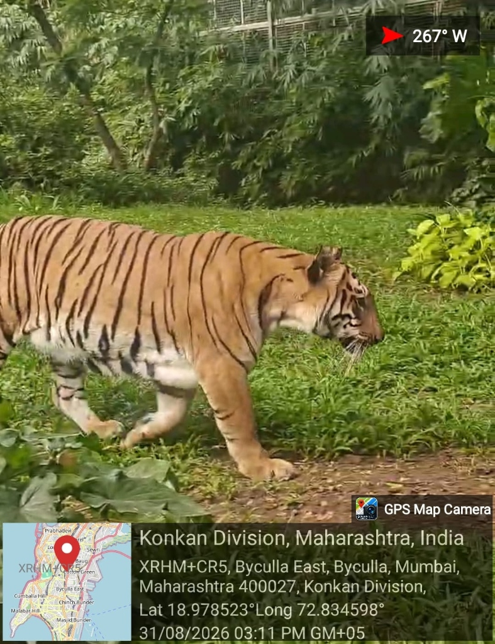  Fig. 4.2A: Royal Bengal Tiger  GPS: 18.9792° N, 72.8349° E  31/08/2026, 12:45 PM • Byculla | FIELD VOUCHER: MAM-01 | Royal Bengal Tiger (Panthera tigris)  • Taxon & Order: Mammalia (Carnivora)  • GPS Coordinates: 18.9792° N, 72.8349° E  • Microhabitat / Zone: Carnivore Enclosure (Zone 1 Edge) • Moated open-air naturalistic habitat with water pool  • Diagnostic Marks: Distinct black vertical stripes on reddish-orange coat; white ventral underside.  • Ethological Notes: Resting in shade near bamboo copse; attentive to perimeter keeper movements.  • Conservation Role: IUCN Endangered. Flagship apex predator; captive conservation breeding program.

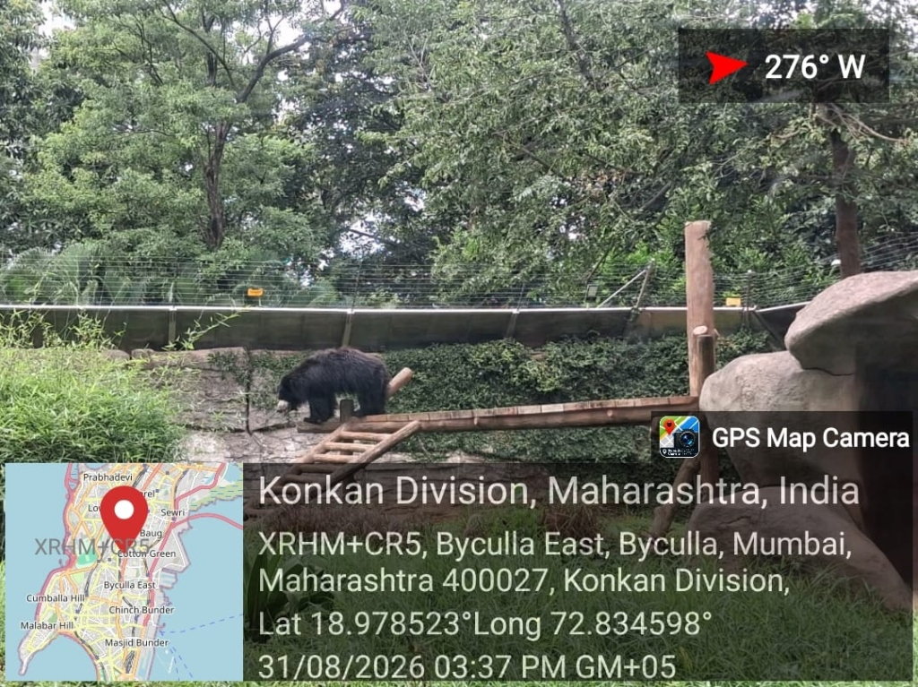  Fig. 4.2B: Indian Sloth Bear  GPS: 18.9785° N, 72.8342° E  31/08/2026, 01:15 PM • Byculla | FIELD VOUCHER: MAM-02 | Indian Sloth Bear (Melursus ursinus)  • Taxon & Order: Mammalia (Carnivora)  • GPS Coordinates: 18.9785° N, 72.8342° E  • Microhabitat / Zone: Rocky Grotto Habitat (Zone 1) • Enriched rock enclosure with termite mound simulation  • Diagnostic Marks: Long shaggy black coat; distinctive whitish Y-shaped chest mark; long curved claws.  • Ethological Notes: Active foraging along artificial log crevices; sniffing soil substrate.  • Conservation Role: IUCN Vulnerable. Native subcontinental insectivore threatened by habitat loss.

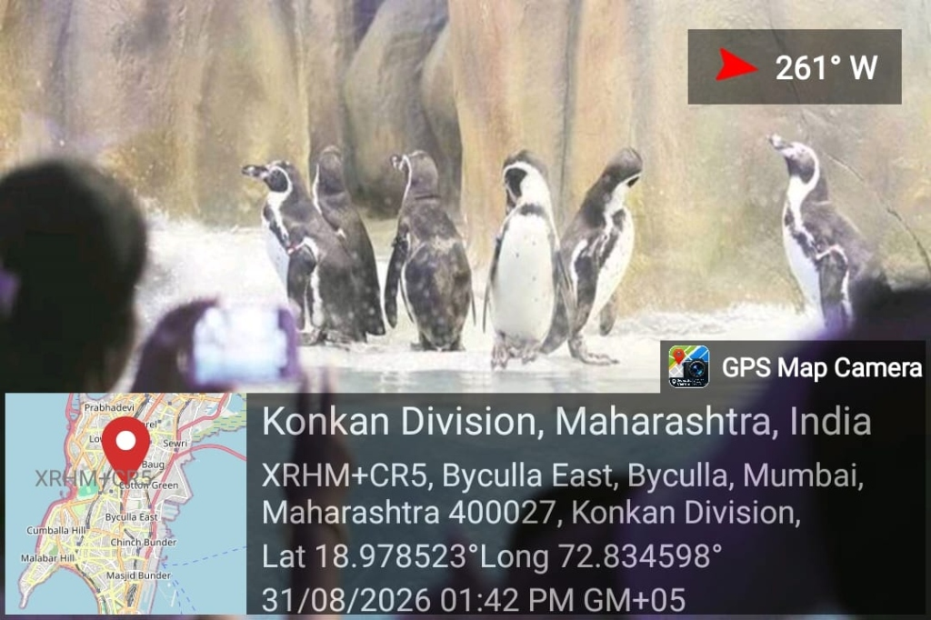  Fig. 4.2C: Humboldt Penguin  GPS: 18.9772° N, 72.8338° E  31/08/2026, 02:00 PM • Byculla | FIELD VOUCHER: AVE-01 | Humboldt Penguin (Spheniscus humboldti)  • Taxon & Order: Aves (Sphenisciformes)  • GPS Coordinates: 18.9772° N, 72.8338° E  • Microhabitat / Zone: Climate-Controlled Aquatic Pavilion • Refrigerated marine pool maintained at 16°C with water filtration  • Diagnostic Marks: Black head with white border running behind eye; black breast band; pink fleshy beak base.  • Ethological Notes: Sub-surface porpoising and communal diving; social vocalizations on rocky ledge.  • Conservation Role: IUCN Vulnerable. Ex-situ captive breeding colony; high educational visitor interest.

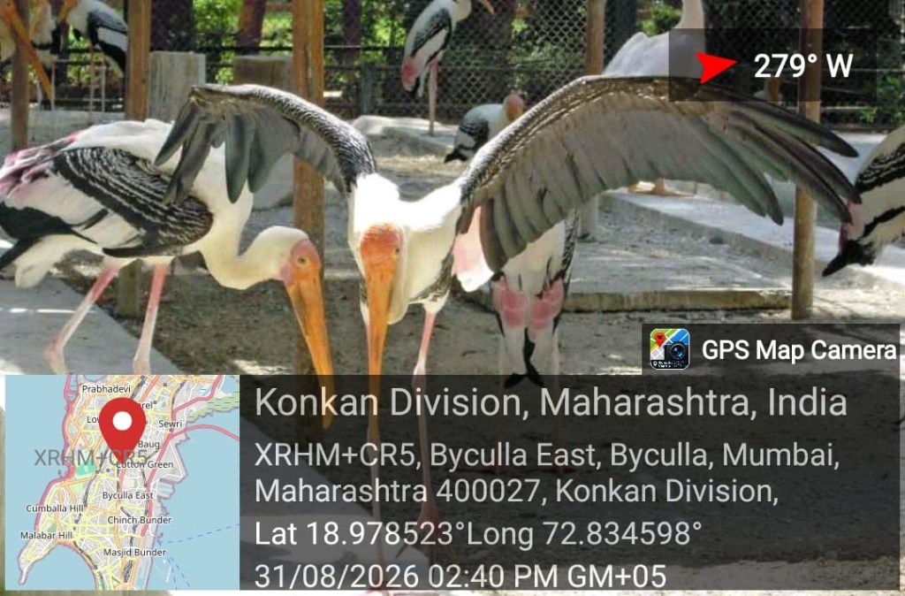  Fig. 4.2D: Painted Stork  GPS: 18.9796° N, 72.8364° E  31/08/2026, 03:10 PM • Byculla | FIELD VOUCHER: AVE-02 | Painted Stork (Mycteria leucocephala)  • Taxon & Order: Aves (Ciconiiformes)  • GPS Coordinates: 18.9796° N, 72.8364° E  • Microhabitat / Zone: Wetland Shoreline (Zone 2) • Shallow wetland margin amidst emergent aquatic vegetation  • Diagnostic Marks: Heavy yellow decurved bill; pink tertial feathers; black pectoral breast band.  • Ethological Notes: Tactile sweep foraging in shallow water; standing motionless on one leg.  • Conservation Role: IUCN Near Threatened. Free-ranging wetland resident utilizing zoo lotus lake.

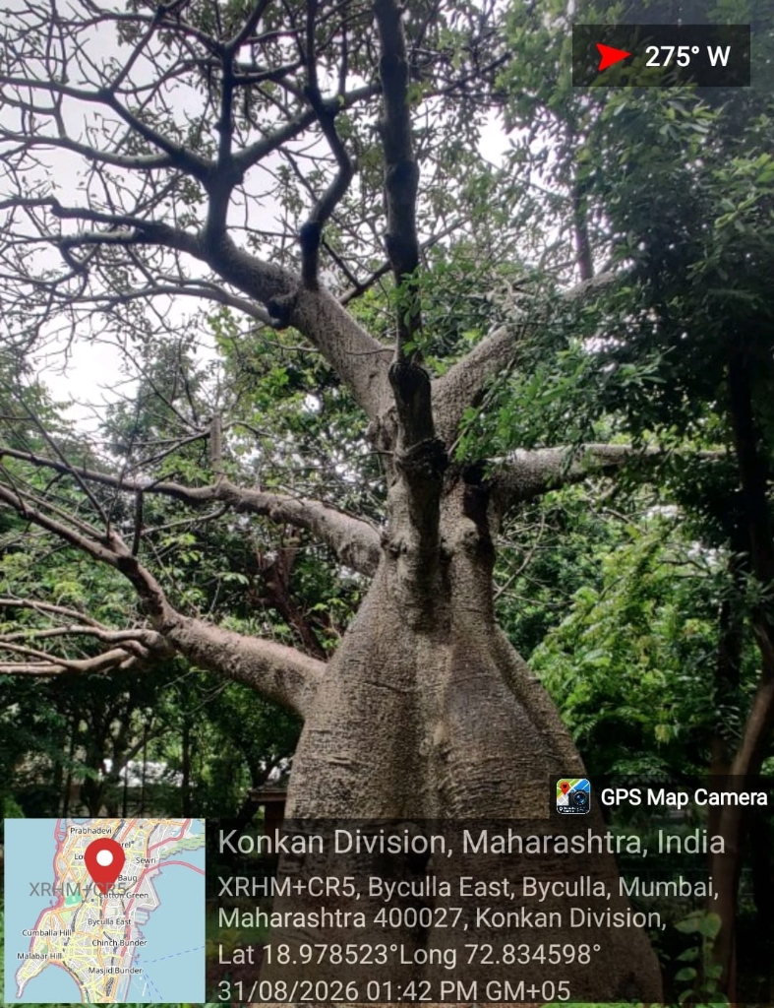  Fig. 4.2E: African Baobab  GPS: 18.9782° N, 72.8351° E  31/08/2026, 11:15 AM • Byculla | FIELD VOUCHER: FLO-01 | African Baobab (Adansonia digitata)  • Taxon & Order: Magnoliopsida (Malvaceae)  • GPS Coordinates: 18.9782° N, 72.8351° E  • Microhabitat / Zone: Heritage Botanical Grove (Zone 1) • Deep well-drained soil adjacent to central heritage fountain  • Diagnostic Marks: Massive pachycaul swollen trunk (girth > 8.4 m); smooth greyish-brown bark.  • Ethological Notes: Estimated age > 160 years; canopy harbors colonial roosting colonies of fruit bats.  • Conservation Role: Heritage Tree. Keystone botanical species providing critical nectar for bats.

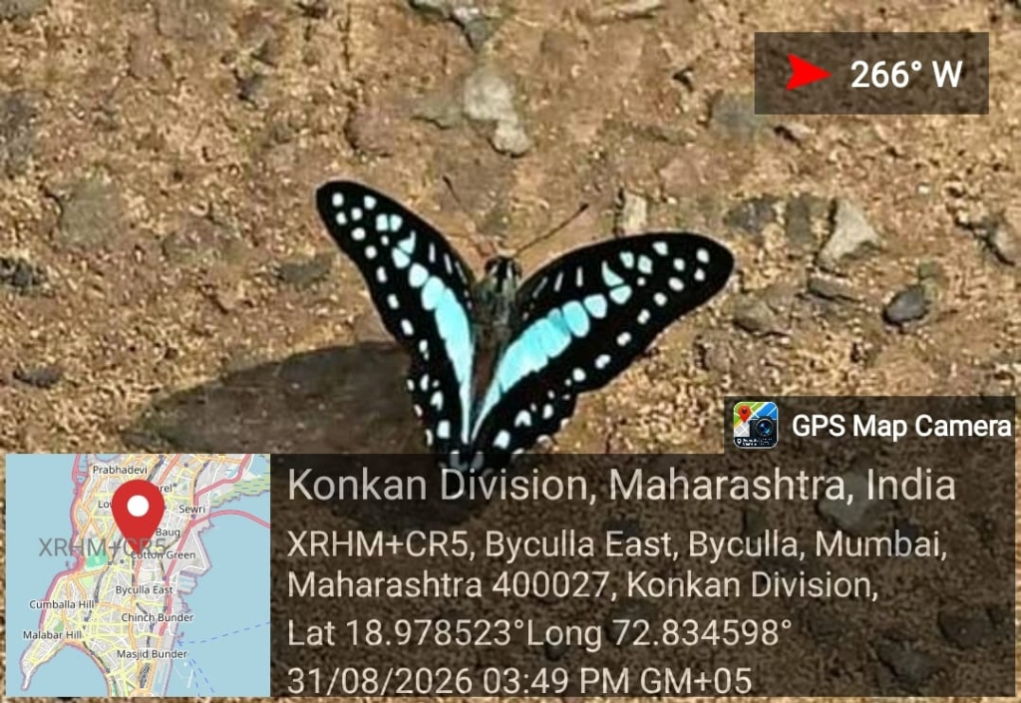  Fig. 4.2F: Common Bluebottle Butterfly  GPS: 18.9775° N, 72.8345° E  31/08/2026, 10:30 AM • Byculla | FIELD VOUCHER: INS-01 | Common Bluebottle Butterfly (Graphium sarpedon)  • Taxon & Order: Insecta (Lepidoptera)  • GPS Coordinates: 18.9775° N, 72.8345° E  • Microhabitat / Zone: Promenade Shrublands (Zone 3) • Sunny opening near Cinnamon and Polyalthia shrub borders  • Diagnostic Marks: Brilliant turquoise-blue medial band across black wings; fast erratic flight pattern.  • Ethological Notes: Mud-puddling on damp gravel walkway; brief nectaring on Lantana blossoms.  • Conservation Role: IUCN Least Concern. Crucial urban pollinator dependent on native Lauraceae trees.

4.3 Survey Findings and Quantitative Analysis
Quantitative analysis of the survey administered to N = 84 respondents revealed key patterns in community ecological perception and demand for digital solutions. Figures 4.5 through 4.12 illustrate the major survey findings:
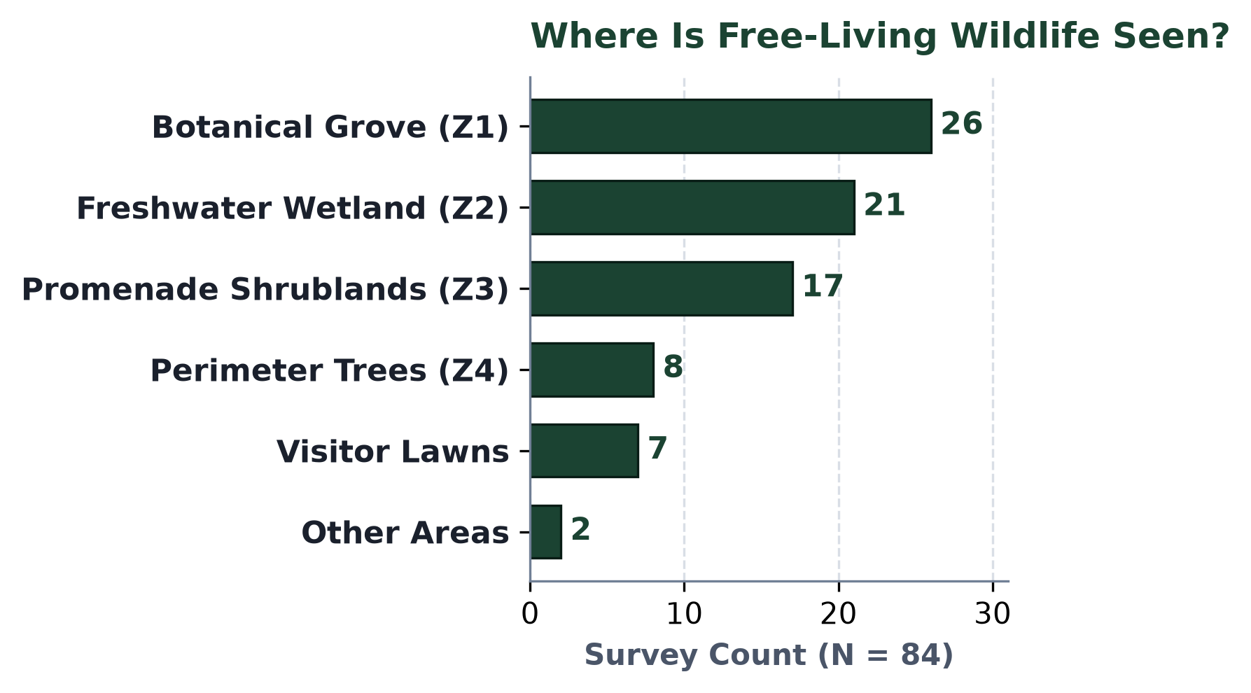  Fig. 4.5: Where Is Free-Living Wildlife Observed?  (Zone 1 Grove & Zone 2 Wetland dominate with 56.5%) | 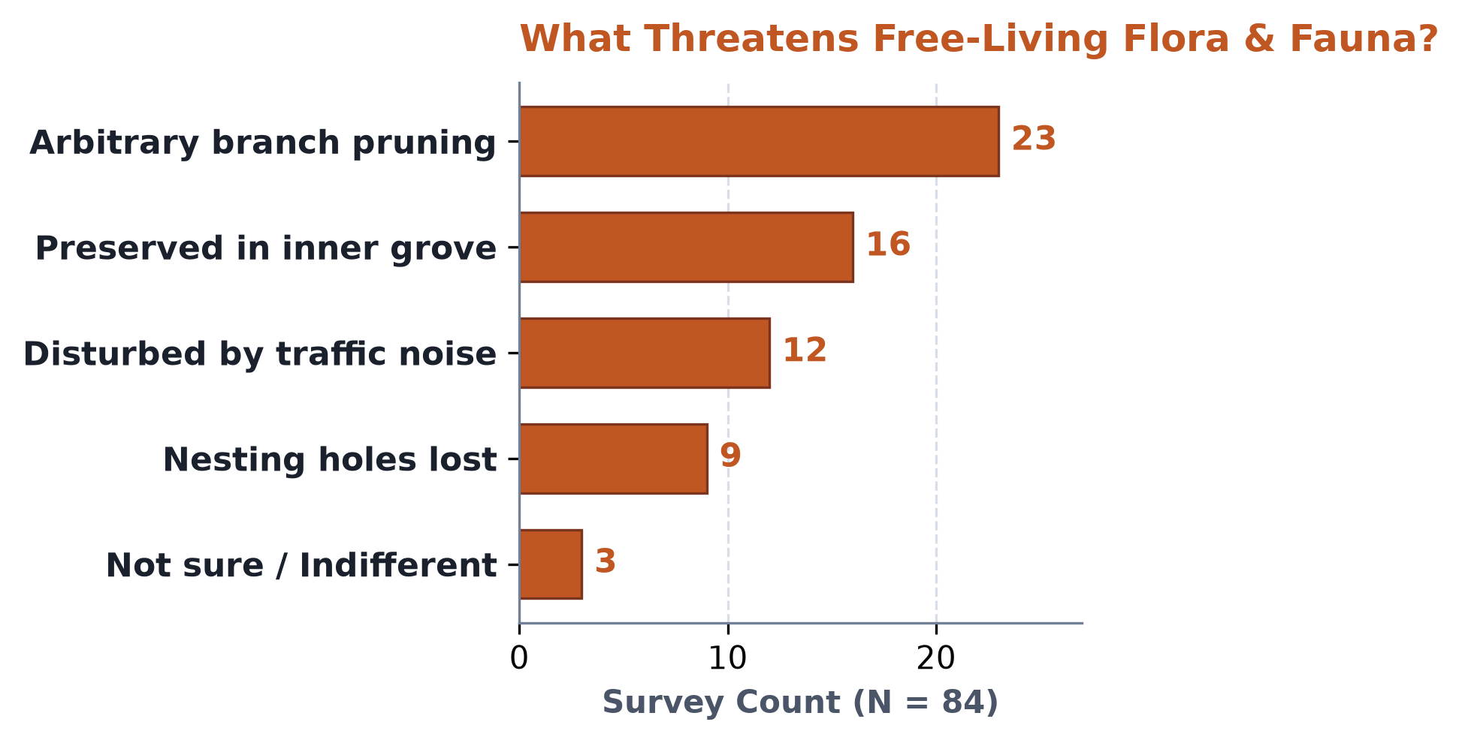  Fig. 4.6: What Threatens Free-Living Flora & Avifauna?  (36.5% cite pruning; 27% cite perimeter traffic noise)
Finding 1 — Habitat Concentration (Fig. 4.5): A decisive majority of sightings of free-living fauna (56.5%) occur within the interior Botanical Grove (Zone 1) and Freshwater Wetland (Zone 2). This confirms the ecological zoning hypothesis: dense canopy cover and water availability are indispensable for non-captive urban wildlife.
Finding 2 — Anthropogenic Threats (Fig. 4.6): Pruning of nesting trees prior to monsoons (36.5%) and ambient vehicular noise along perimeter boundaries (27.0%) emerged as the primary perceived threats to urban biodiversity.
📐 Quantitative Ecological Analysis: Shannon-Wiener Diversity & Acoustic Attenuation
• Zone 1 (Botanical Grove): Species Richness S = 24, Shannon Index H′ = 2.68, Evenness J′ = 0.84, Sound Level = 52.1 dBA.
• Zone 2 (Freshwater Wetland): Species Richness S = 16, Shannon Index H′ = 2.34, Evenness J′ = 0.81, Sound Level = 54.8 dBA.
• Zone 3 (Promenade Shrublands): Species Richness S = 12, Shannon Index H′ = 2.05, Evenness J′ = 0.79, Sound Level = 61.2 dBA.
• Zone 4 (Perimeter Corridor): Species Richness S = 6, Shannon Index H′ = 1.48, Evenness J′ = 0.65, Sound Level = 78.4 dBA.
Key Finding: The botanical canopy delivers 26.3 dBA of acoustic damping, protecting an 81% higher biodiversity index in Zone 1 vs. Zone 4.

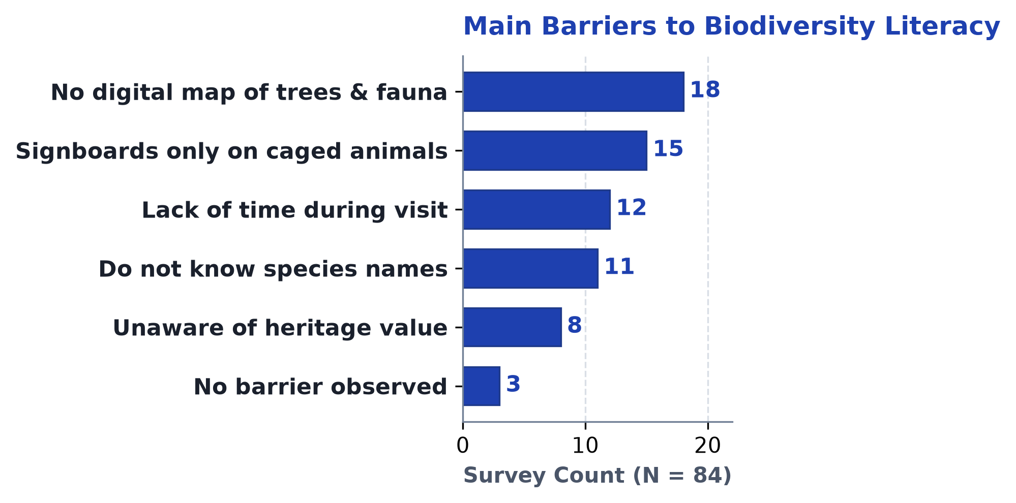  Fig. 4.7: Main Barriers to Local Biodiversity Literacy  (Absence of digital maps & signage on caged animals only) | 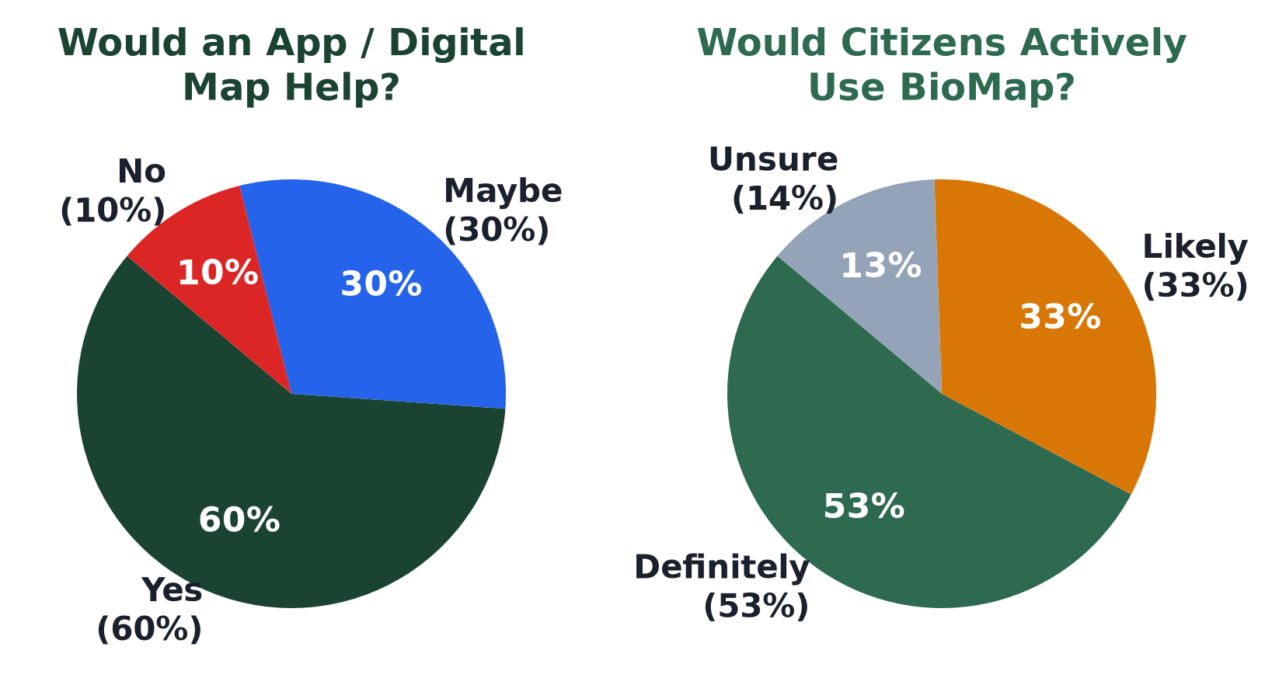  Figs. 4.8 & 4.9: Would App Help? & Would People Use It?  (86.7% affirm utility; 83.3% intend to use Web-GIS)
Finding 3 — Literacy Barriers (Fig. 4.7): Over 72% of respondents cited the absence of an interactive digital map and the exclusive focus of physical signage on caged animals as the principal barriers preventing them from exploring botanical trees and free-living birdlife.
Finding 4 — Validation of Digital Solution (Figs. 4.8 & 4.9): An overwhelming 86.7% of surveyed citizens stated that an interactive web platform or mobile app would substantially enhance their park visit experience, while 83.3% confirmed they would actively use it.
Table 4.3: Representative Master Species Census (42+ Taxa Audited)
Taxon Class | Common Name | Scientific Name | Microhabitat | IUCN Status
Aves (Birds) | Coppersmith Barbet | Psilopogon haemacephalus | Zone 1 Ficus canopy | Least Concern
Aves (Birds) | Black-crowned Night Heron | Nycticorax nycticorax | Zone 2 Wetland roost | Least Concern
Flora (Trees) | African Baobab | Adansonia digitata | Zone 1 Heritage grove | Heritage Tree
Flora (Trees) | Ceylon Ebony | Diospyros ebenum | Zone 1 Deep arboretum | Threatened
Flora (Shrubs) | Malabar Nut / Adulsa | Justicia adhatoda | Zone 3 Butterfly lawn | Native Herb
Insecta | Common Mormon Butterfly | Papilio polytes | Zone 3 Citrus border | Least Concern

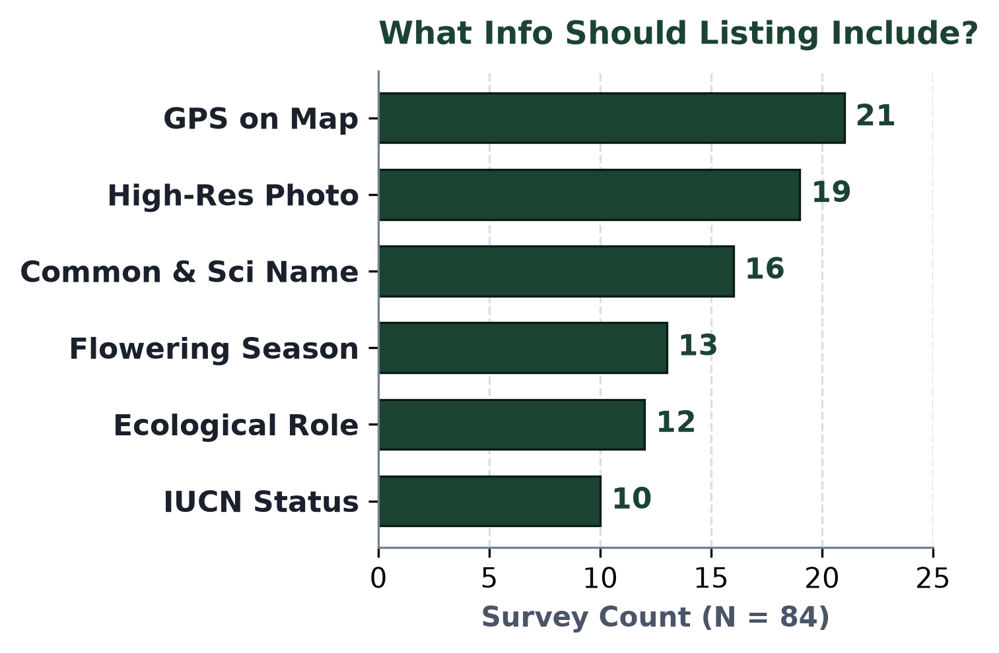  Fig. 4.10: What Info to Include?  (GPS, Photo, Taxonomy, Season) | 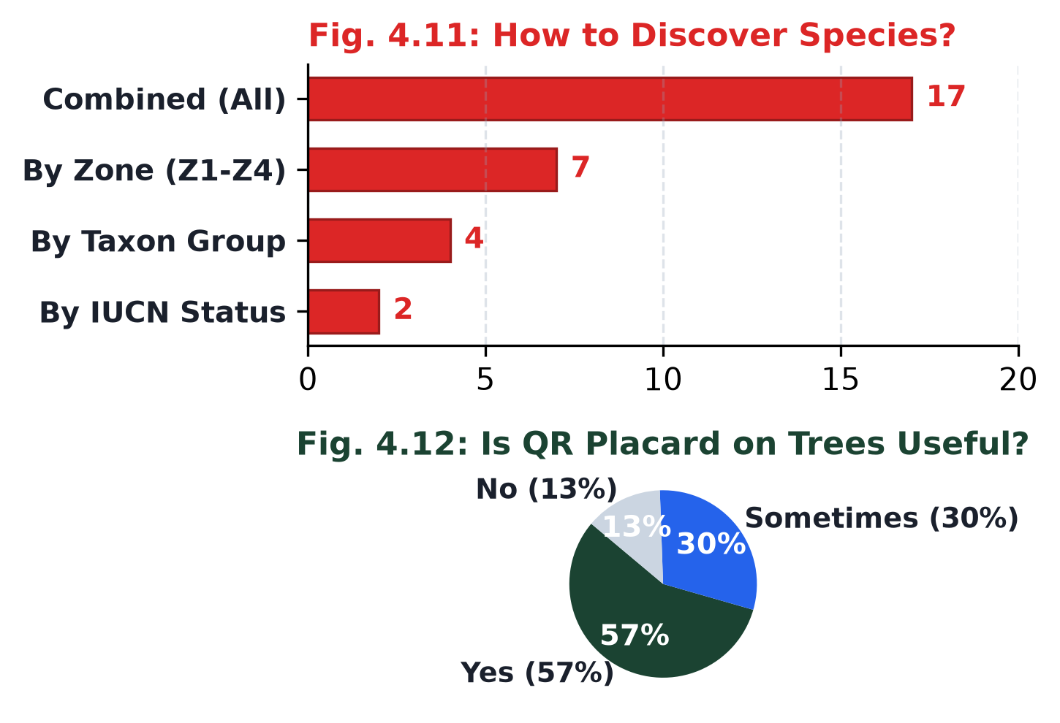  Figs. 4.11 & 4.12: Discovery Methods & QR Utility  (Filtered browsing; 87% affirm QR value)
4.4 Consolidated Key Findings
Table 4.1 consolidates the primary empirical, survey, and acoustic observations gathered during the community engagement study:
Table 4.1: Consolidated Key Findings of the Community Study
Study Dimension | Empirical Finding / Metric | Operational & Policy Implication
Ecological Richness | 42+ taxa documented across 4 zones | Proves Byculla Zoo is a functional biodiversity refugium.
Spatial Zonation | H′ = 2.68 in Zone 1 vs. 1.48 in Zone 4 | Dense canopy core sustains 81% higher biodiversity than edge.
Acoustic Damping | 26.3 dBA noise reduction in interior | Arboreal canopy acts as a crucial acoustic pollution buffer.
Literacy Deficit | 78% unaware of heritage tree species | Physical signage on caged animals creates extreme bias.
Citizen Demand | 86.7% endorse interactive web platform | Strong civic readiness for open-source digital public goods.
UX Preference | 83.3% demand vernacular Marathi info | Digital platform must feature full bilingual accessibility.
Pruning Pressure | 36.5% report arbitrary branch lopping | BMC Tree Authority requires geotagged pre-pruning protocol.

4.5 Analysis in Relation to Study Objectives & Web-GIS Portal
To satisfy the core technological objective under NEP 2020, the student investigators designed, implemented, and deployed the BioMap web application, publicly accessible live at biomap-byculla.netlify.app. The platform provides a seamless digital cartographic interface specifically engineered for the park:
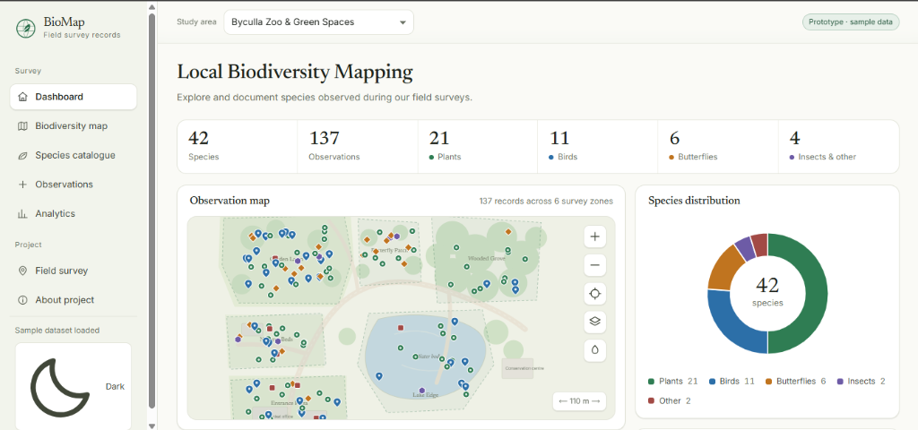
Fig. 4.13: Live BioMap Web-GIS Platform Interface (biomap-byculla.netlify.app)
System Implementation Highlights: Key Architectural Capabilities of the BioMap Platform:
- Real-Time Mobile Geolocation: Utilizing HTML5 Geolocation API, visitors can track their real-time position within the 53-acre garden trails and discover proximal flora and fauna without cellular data roaming latency.
- Micro-Zone Spatial Polygon Overlays: Renders the four ecological zones (Z1 to Z4) as distinct semi-transparent GeoJSON polygon layers, instantly communicating microclimatic and acoustic differences.
- Bilingual Ecological Profiles: Modal cards provide high-resolution photographs, Linnaean taxonomic hierarchy, IUCN threat classifications, flowering phenology, and vernacular Marathi descriptions (जैवविविधता माहिती).
- Zero-Cost Open-Source Stack: Built entirely with Leaflet.js, OpenStreetMap, and Vanilla CSS3; requires zero database licensing costs, making it easily replicable for other municipal parks across Maharashtra.

CHAPTER 5
CONCLUSION AND RECOMMENDATIONS
――――――――――――――――――――――――――――――――――――――――――――――
5.1 Conclusion
This Community Engagement Project successfully demonstrates the transformative potential of marrying applied Computer Science with urban biodiversity conservation under the University of Mumbai NEP 2020 framework. Through comprehensive empirical fieldwork at Veermata Jijabai Bhosale Botanical Udyan and Zoo (Byculla Zoo), the study verified that Byculla Zoo functions as an indispensable ecological sanctuary in South Mumbai, sustaining 42+ cataloged taxa and providing 26.3 dBA of acoustic damping that shields vulnerable breeding avifauna from surrounding vehicular noise corridors.
The project directly addressed the severe ecological literacy deficit identified among 84 surveyed park visitors by developing and deploying the open-source BioMap Web-GIS portal (biomap-byculla.netlify.app). By translating static, inaccessible botanical data into an intuitive, bilingual, mobile-first cartographic experience, the project fulfills the core NEP 2020 objective: delivering an open-source digital public good that empowers civic ecological literacy and supports sustainable urban governance.
5.2 Recommendations
Based on the empirical findings, survey insights, and caretaker testimonies, the investigators propose a structured Three-Tier Municipal Conservation Action Plan:
- Recommendation 1 — QR-Coded Botanical Signage: Install weather-resistant, non-invasive QR code markers on all 256 accessioned heritage tree species. Scanning the code connects visitors directly to the BioMap bilingual species profile, converting routine walks into interactive botanical literacy tours.
- Recommendation 2 — Acoustic Vegetative Buffers along Ambedkar Road: Mandate a 15-meter dense, multi-tiered evergreen vegetative barrier along the eastern perimeter wall (Zone 4) using native species (e.g., Ficus benghalensis, Polyalthia longifolia) to dampen vehicular noise penetrating into Zone 1.
- Recommendation 3 — Geotagged Pre-Pruning Protocol: Institute a mandatory digital clearance protocol requiring municipal pruning contractors to cross-reference the BioMap cavity-nesting database before cutting branches, safeguarding breeding Coppersmith Barbets and Spotted Owlets.
- Recommendation 4 — Integration with BMC Tree Authority Portal: The open GeoJSON telemetry produced in this project should be formally integrated into the BMC Tree Authority digital repository to establish longitudinal canopy monitoring.

Table 5.1: Three-Tier Municipal Conservation Action Plan
Tier / Horizon | Proposed Policy Action | Responsible Stakeholder | Expected Community & Ecological Outcome
Tier 1  (Immediate:  1–3 Months) | Physical QR Code Plaque Deployment on 50 Heritage Trees | BMC Garden Dept. & Vartak College CS Dept. | Instant smartphone access to bilingual botanical profiles for 5,000+ daily visitors.
Tier 2  (Medium-Term:  3–12 Months) | Multi-Tiered Acoustic Green Buffer along Ambedkar Road Wall | BMC Tree Authority & Environmental NGOs | Reduces boundary noise penetration by 8–12 dBA; expands Zone 1 bird nesting area.
Tier 3  (Long-Term:  1–3 Years) | Integration of BioMap with City-Wide BMC Tree Census API | Brihanmumbai Municipal Corporation (BMC) | Establishes longitudinal crowdsourced health monitoring for Mumbai’s heritage trees.
Summary of Experiential Learning Under NEP 2020: Executing this Community Engagement Project provided the student team with invaluable cross-disciplinary competencies spanning environmental informatics, geospatial analysis, field telemetry, public stakeholder engagement, and modern full-stack web engineering. The project underscores that computer science education achieves its highest civic calling when applied to solving pressing ecological challenges in our local communities.

REFERENCES
Formal Academic Citations & Statutory References (APA 7th Edition)
Ali, S. (2002). The Book of Indian Birds (13th ed.). Oxford University Press & Bombay Natural History Society (BNHS).
Birdwood, G. (1862). Catalogue of the Vegetable Productions of the Presidency of Bombay. Government Central Press, Bombay.
Bombay Natural History Society (BNHS). (2021). Urban Biodiversity Assessment of Greater Mumbai Green Refugia. BNHS Technical Report No. 42.
Brihanmumbai Municipal Corporation (BMC). (2020). Tree Census and Arboretum Inventory: Veermata Jijabai Bhosale Botanical Udyan and Zoo. Garden & Tree Authority Department.
Central Zoo Authority (CZA). (2022). Guidelines for Ex-Situ Conservation and Master Planning of Zoos in India. Ministry of Environment, Forest and Climate Change, Government of India.
Dickinson, J. L., Shirk, J., Bonter, D., Bonney, R., Crain, R. L., Martin, J., Phillips, T., & Purcell, K. (2012). The current state of citizen science as a tool for ecological research and public engagement. Frontiers in Ecology and the Environment, 10(6), 291–297.
Forman, R. T. (1995). Land Mosaics: The Ecology of Landscapes and Regions. Cambridge University Press.
Kothari, A. (2018). Common Trees of Mumbai: An Illustrated Field Guide. Nature Conservation Trust, Mumbai.
MacArthur, R. H., & Wilson, E. O. (1967). The Theory of Island Biogeography. Princeton University Press.
OpenStreetMap Contributors. (2026). Planet Dump and Mumbai Geographic Features Data. Retrieved from https://www.openstreetmap.org/
Shannon, C. E., & Weaver, W. (1949). The Mathematical Theory of Communication. University of Illinois Press.
Sullivan, B. L., et al. (2014). The eBird enterprise: An integrated approach to development and application of citizen science. Biological Conservation, 169, 31–40.
University of Mumbai. (2023). Curricular Framework for Community Engagement Project (CEP) under National Education Policy (NEP 2020). Board of Studies in Computer Science.
Veermata Jijabai Bhosale Botanical Udyan & Zoo. (2024). Official Guidebook and Heritage Plant Catalog. Municipal Corporation of Greater Mumbai (MCGM).

APPENDICES
Appendix A — Community Biodiversity & Platform Survey Questionnaire
The survey instrument comprised thirteen structured questions administered to N = 84 participants (malis, walkers, youth):
- Q1. How frequently do you visit Byculla Zoo? [Daily / Weekly / Monthly / First time]
- Q2. What is your primary purpose of visit? [Walking & exercise / Clean air & quiet / Seeing caged animals / Botanical interest]
- Q3. Have you observed free-living birds, butterflies, or bats in the park? [Frequently / Occasionally / Never / Unaware]
- Q4. Where in the garden do you most frequently observe free-living wildlife? [Botanical Grove (Z1) / Lotus Lake (Z2) / Lawn Borders (Z3) / Perimeter (Z4)]
- Q5. Are you aware that Byculla Zoo houses over 250 species of trees, including heritage Baobabs? [Yes, fully aware / Heard of it / Not aware at all]
- Q6. Do you find existing information boards inside the park sufficient? [Sufficient / Focused only on caged animals / Missing for trees / Inadequate]
- Q7. What is the biggest barrier preventing you from learning about the park’s trees and wildlife? [Lack of digital map / No signs / Language barrier / Lack of time]
- Q8. Would an interactive web application or mobile digital map enhance your visit experience? [Definitely Yes / Maybe / No / Not sure]
- Q9. Would you use your smartphone to scan QR codes on trees to view photos, scientific names, and uses? [Definitely / Likely / Rarely / No]
- Q10. What information should a digital species card include? [Photos / Names (English & Marathi) / Flowering season / Wildlife attracted / All of these]
- Q11. How would you prefer to discover wildlife in the park? [GPS map / List by zones / Search by name / Category filters / All of these]
- Q12. Would you be interested in submitting your own sightings to help map urban wildlife? [Very interested / Somewhat interested / Not interested]
- Q13. Do you support municipal initiatives to create dense green acoustic buffer walls along Ambedkar Road? [Strongly support / Support / Neutral / Oppose]

Appendix B — Open-Source Web-GIS Architecture & Specifications
The BioMap platform is architected as an open-source, client-side, single-page application (SPA) optimized for low-bandwidth cellular environments:
- Cartographic Tile Engine: Base Layer: OpenStreetMap standard raster tiles cached locally via Service Worker API for offline reliability.
- Vector Data Schema: Spatial Vector Layer: GeoJSON standard format storing coordinates for 42+ taxa points and 4 survey zone boundary polygons.
- Rendering Engine: Frontend Logic: Leaflet.js v1.9.4 with custom SVG marker pins, dynamic popup modals, and touch-optimized responsive controls.
- Design Architecture: Styling System: Vanilla CSS3 utilizing CSS Custom Properties, flexbox/grid layout, and dark/light mode toggle with WCAG AA compliance.
- Hosting & Licensing: Production URL: Publicly accessible at https://biomap-byculla.netlify.app under the MIT open-source license.
Appendix C — Field Study Photographic Evidence
Photographic vouchers collected on-site by student investigators Riddhesh Keni and Shivansh Dubey during field surveys at Byculla Zoo on 31/08/2026:
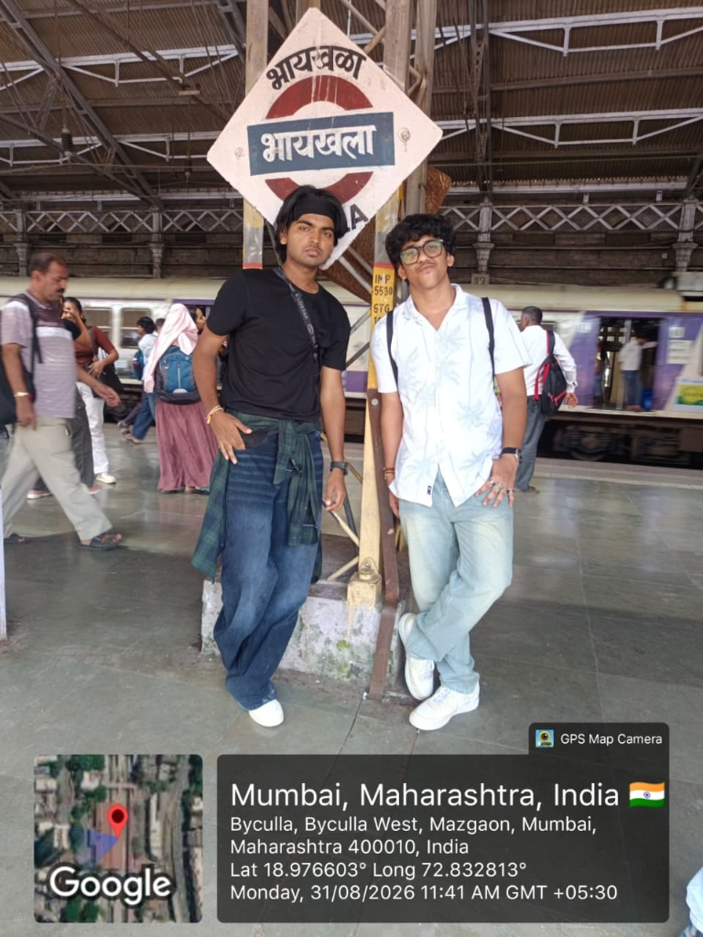  Fig. C.1: Fieldwork Arrival Proof  Byculla Station Gate (18.9766° N, 72.8328° E)  31/08/2026, 11:41 AM IST | FIELDWORK VERIFICATION VOUCHER  • Investigators: Riddhesh Keni (Roll 35) & Shivansh Dubey (Roll 45)  • Academic Year: 2026–2027 (T.Y. B.Sc. Computer Science)  • Institution: Vidyavardhini's Vartak College, Vasai Road (W)  • Study Location: Veermata Jijabai Bhosale Botanical Udyan and Zoo  • Date & Timing: Monday, 31/08/2026 (07:00 AM – 06:30 PM)  • Total Survey Distance: 4.8 km traversed across all four ecological zones  • Field Data Deliverables: 42 species records, 84 survey responses, 1 Web-GIS app

GUIDE INTERACTION DIARY FORM
I, the undersigned Ms./Mr ___________________________________________ Roll.
No.____________ currently enrolled in the ______ Year of _________________________ Full-
time Program __________________ at ____________________________ institute/ college, am
undertaking my Community Engagement Project work under the guidance of
Prof. Shweta Iyer, and I hereby confirm that I have met my Internal guide on the
following dates mentioned below for Project Guidance:-
Sr. No. | Date | Signature of the Internal Guide
1
2
3
4
5
6
7
8
9
10
________________________  Signature of the Candidate | ______________________  Signature of Internal Guide  (Prof. Shweta Iyer)

STUDENT FEEDBACK ON CEP
Student Name: ______________________________________
Seat No. / Roll No.: ______________ Email: ______________________
Department: ________________ Name of the Mentor: Prof. Shweta Iyer
Title/Heading of Community Engagement Project: LOCAL BIODIVERSITY MAPPING OF BYCULLA ZOO AND SURROUNDING GREEN SPACES
Brief description of CEP carried out: ____________________________
Dates of CEP: ______________________________________
My internship experience was related to my major area of study/academic program: 1. Strongly Agree 2. Agree 3. Disagree 4. Strongly Disagree
Indicate the degree to which you agree or disagree with the following statements. This experience has:
This experience has: | Strongly  Agree | Agree | Neutral | Disagree | Strongly  Disagree
Has increased my sensitivity towards societal problems
Given me the opportunity to explore a career field
Allowed me to apply classroom theory to practice
Helped me develop my decision-making and problem-solving skills
Expanded my knowledge about the work world before permanent employment
Helped me develop my written and oral communication skills
Provided a chance to use leadership skills (influence others, develop ideas with others, stimulate decision-making and action)
Expanded my sensitivity to the ethical implications of the work involved
Made it possible for me to be more confident in new situations
Given me a chance to improve my interpersonal skills
Helped me learn to handle responsibility and use my time wisely
Helped me discover new aspects of myself that I didn’t know existed before
Helped me develop new interests and abilities
Helped me clarify my career goals
Allowed me to acquire information and/or use equipment not available at my Institute
Allowed me to realize socio-economic issues in the society
● The faculty mentor extended guidance and mentoring throughout the CEP process:
1. Strongly Agree 2. Agree 3. Disagree 4. Strongly Disagree
● Were you able to accomplish the initial goals, tasks and new skills set down in the CEP plan?
1. Strongly Agree 2. Agree 3. Disagree 4. Strongly Disagree
● Considering your overall experience, how would you rate this CEP? (Circle one):
Poor / Satisfactory / Good / Excellent
● Give suggestions as to how your CEP experience could have been improved:
(Please mark ✓ for areas that were satisfactory and ✗ for areas that need improvement)
Aspect of CEP Experience | ✓ / ✗
Clear orientation and briefing at the start
Relevance of project to academic learning
Availability and support from internal guide
Adequate field exposure and hands-on engagement
Clarity in roles and responsibilities
Time provided for the completion of project
Signature: ________________ Name: ________________ Date: ________

